9 of the Best Homes with Roof Terraces
From Kensington to Cornwall, these are the best homes with roof terraces on the market right now...
4th June 2018
BY ANNIE COLLYER

https://www.countryandtownhouse.co.uk/cth-life/properties/best-properties-roof-terraces/

9. Greybrook House, London
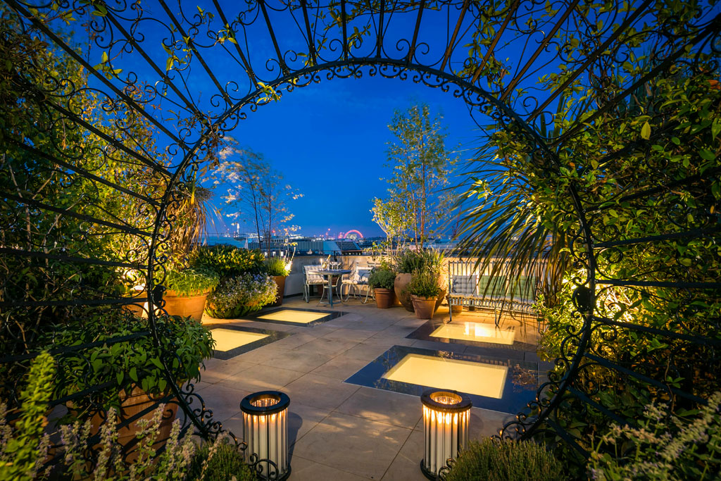
This Art Deco Grade II listed building was originally designed by Sir John Burnett & Partners as a piano showroom. Newly refurbished to an exceptionally high standard, the duplex penthouse is spread over 2 floors and features an immaculate wrap around reception terrace and a large roof garden. The furnished roof garden can be accessed from the L-shaped principal reception space and makes the perfect place to enjoy alfresco dining in the summertime. The large reception terrace features an abundance of plants and foliage, as well as lighting features and the most sensational views over Mayfair and the City of London. Available through Knight Frank for £25m.

